5.1 Simple and weighted results
The underlying calculations
The underlying calculations can be expressed as follows.
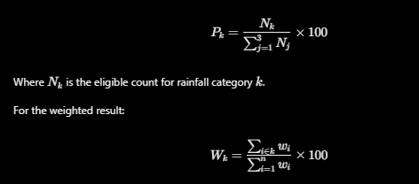
5.3 Indicator weighting and global prior multipliers
The workbook's Prior Multipliers sheet describes a composite priority score based on prevalence, reliability and lead time:

Here, \(P\), \(R\) and \(L\) denote the prevalence, reliability and lead-time scores used by the workbook's priority matrix. The proposed multiplier is obtained by normalizing the composite score against its mean.

The tally


